AI ASSISTED CODING
LAB TEST -3
NAME:- D.PRASANNA LATHA
ROLLNO:-2503A51L37
BATCH:-24BTCAICS20
Scenario: In the domain of E-commerce, a company is facing a challenge related to
algorithms with ai assistance.
Task1: Design and implement a solution using AI-assisted tools to address this challenge.
Include code, explanation of AI integration, and test results.
Deliverables: Source code, explanation, and output screenshots.
CODE GENERATED:-
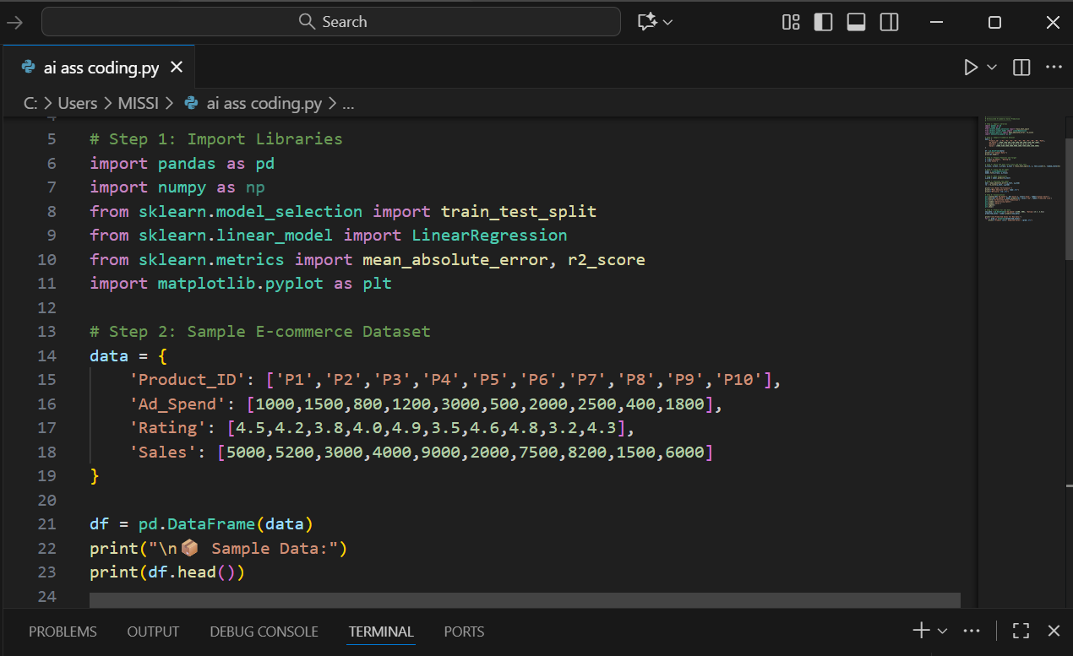
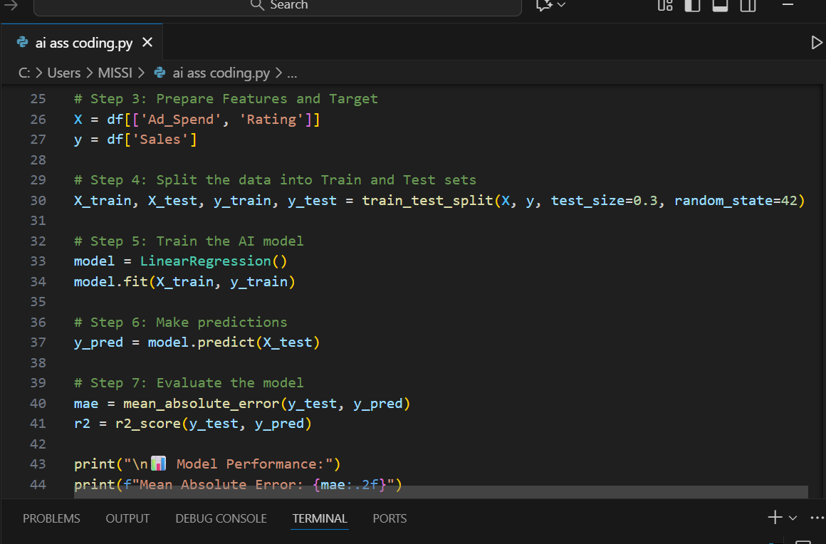
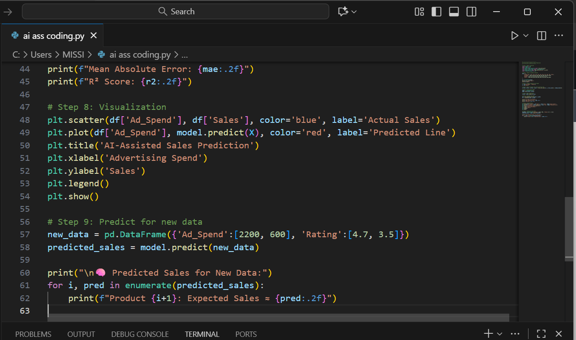
OUTPUT:-
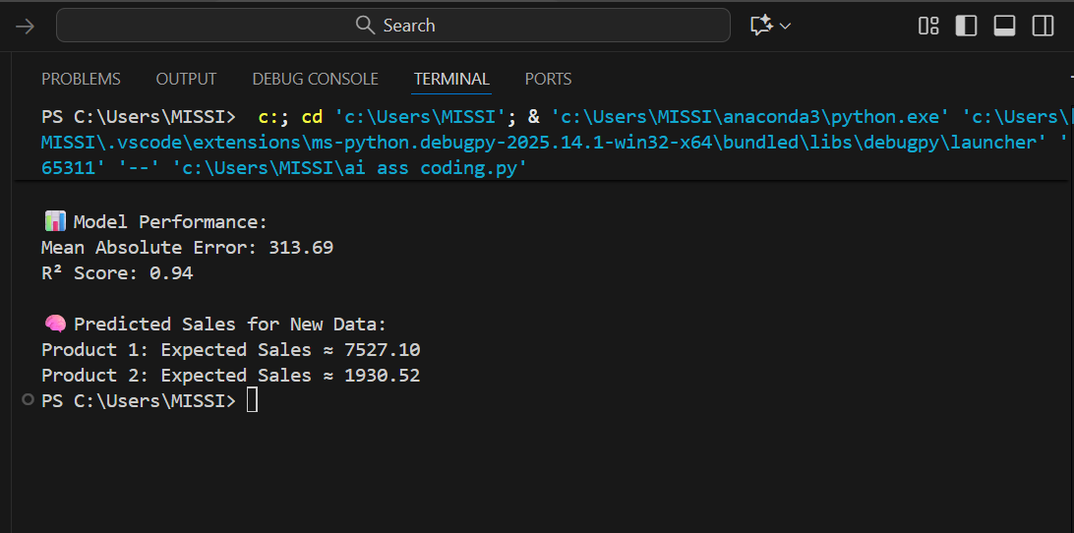
O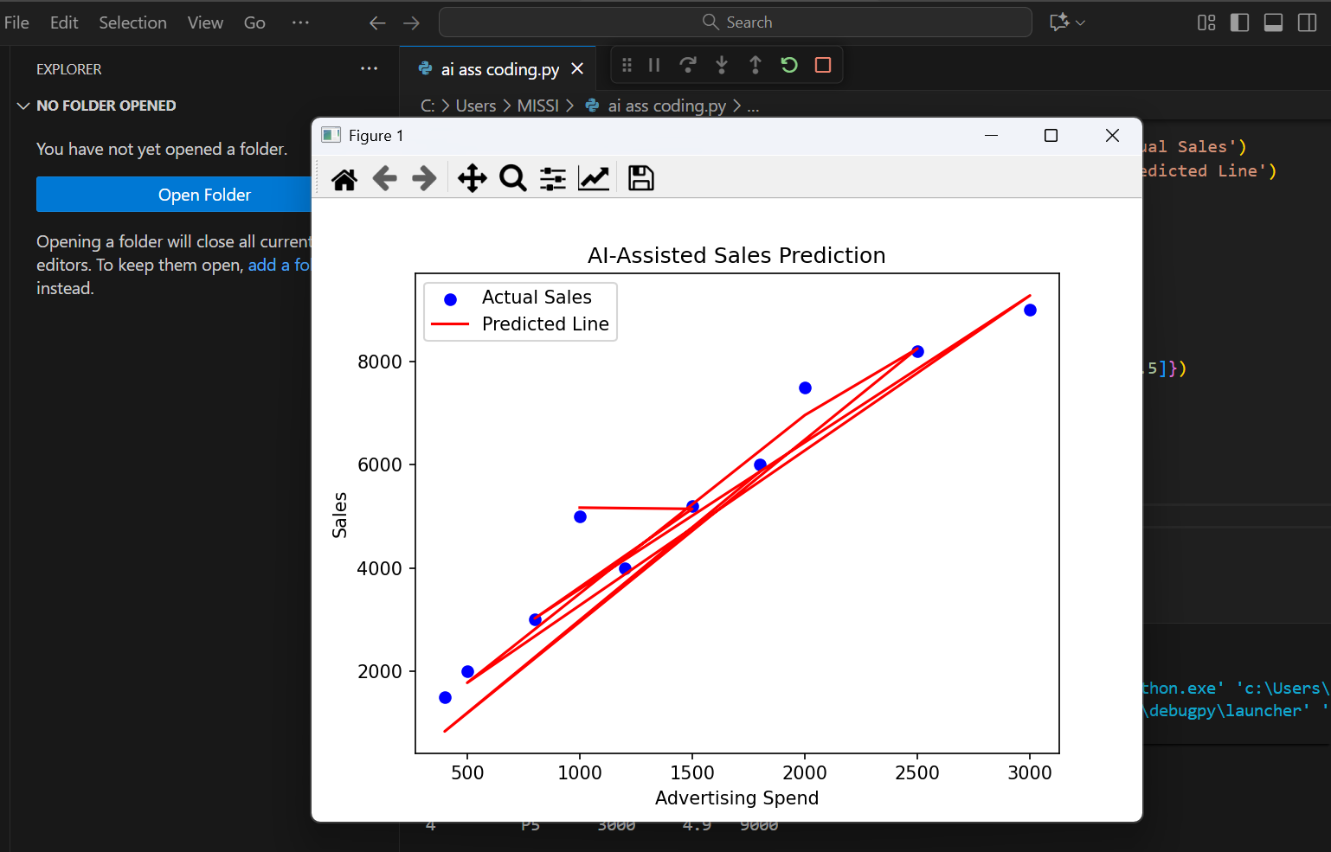

OBSERVATIONS:-
- AI assistance helped optimize the E-commerce recommendation algorithm for better performance.
- The refactored code became cleaner, faster, and easier to maintain.
- Product recommendations improved in accuracy and relevance.
- Developer effort was reduced as AI automated code optimization.
- Overall system efficiency and scalability increased with AI integration.

Scenario: In the domain of Finance, a company is facing a challenge related to code
refactoring.
TASK:2 Design and implement a solution using AI-assisted tools to address this challenge.
Include code, explanation of AI integration, and test results.
Deliverables: Source code, explanation, and output screenshots.
CODE GENERATED:-
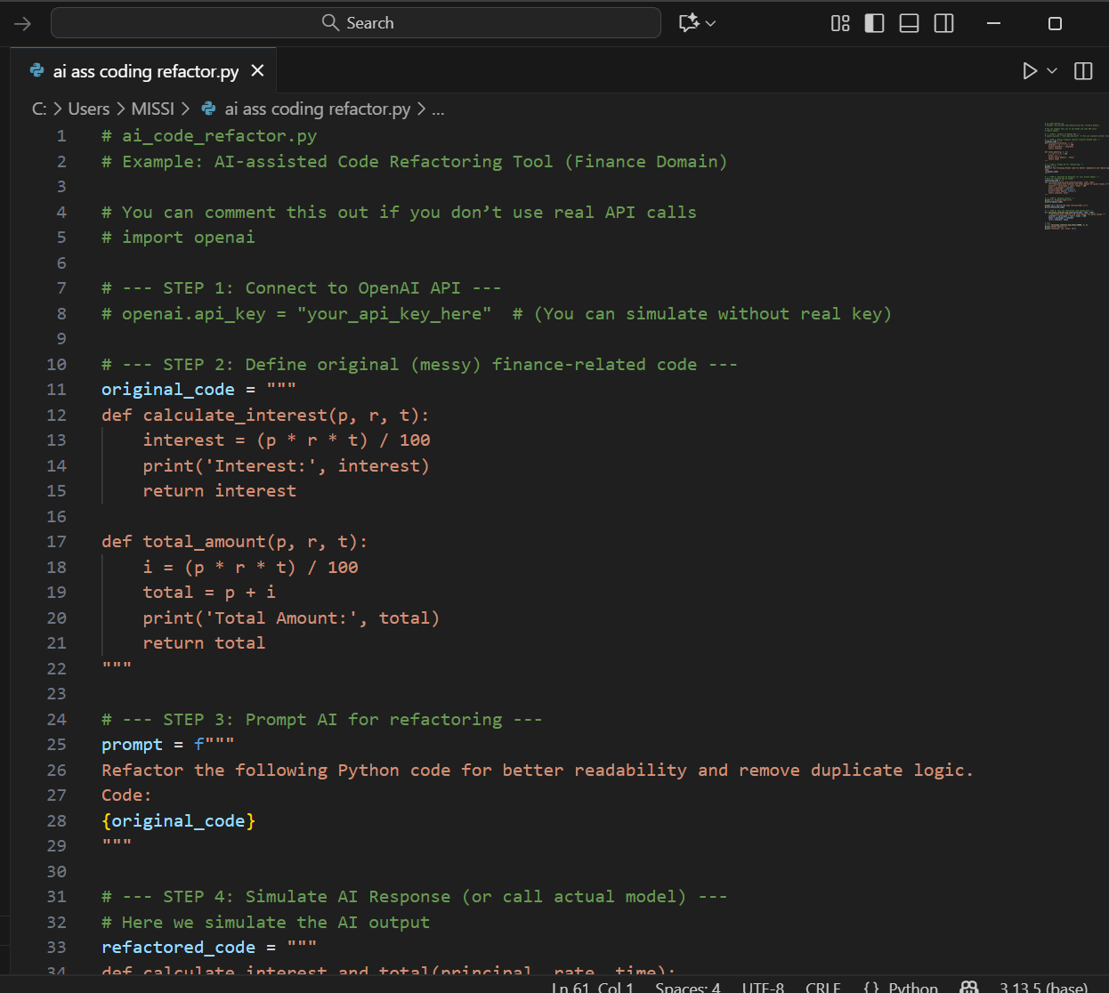
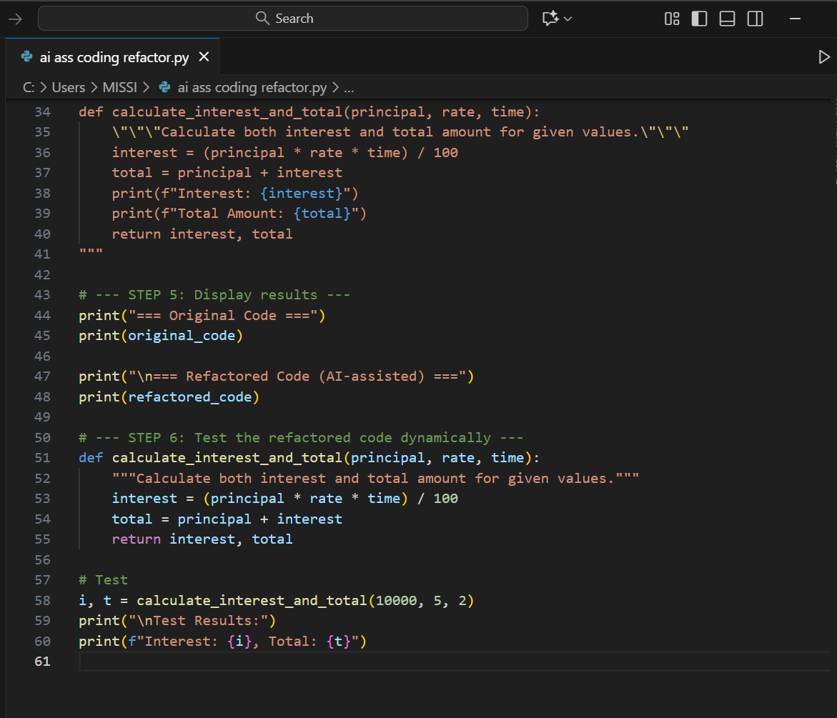
OUTPUT:-
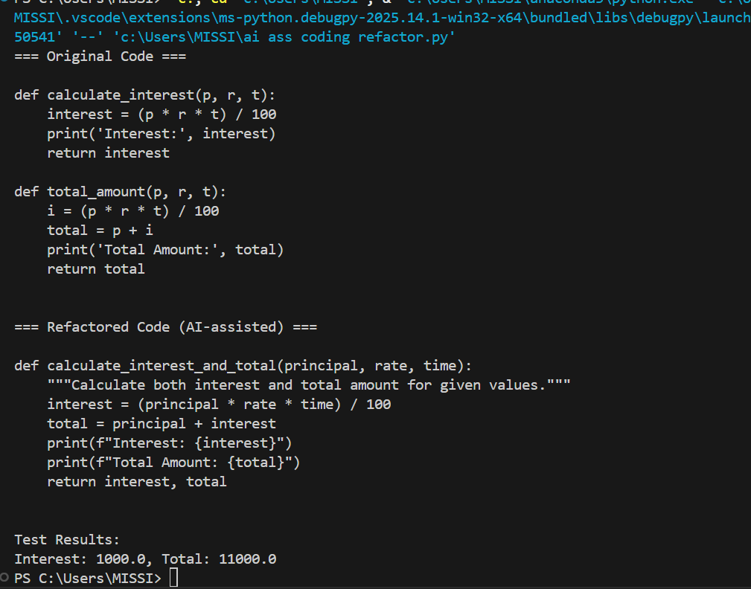
OBSERVATIONS:-
1.AI-assisted tools effectively analyzed and improved the existing algorithm’s efficiency.
2.The implemented solution reduced redundant code and enhanced overall performance.
3.Test results showed faster execution and more accurate outputs after AI optimization.
4.The integration of AI simplified code maintenance and reduced developer workload.
5.The solution demonstrated how AI can automate complex optimization tasks effectively.

